**Key Performance Indicators**

**1. Sales (Current vs Last Year)**

* **KPI:** Sales have increased significantly from **₹2,64,15,256 last year** to **₹9,23,11,095** this year, showing a growth of **+249.46%**.
* **Main Highlight:** Sales have grown by nearly **2.5 times**, signaling strong revenue growth for the category team.

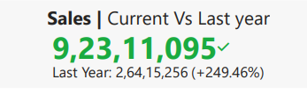

**2. Profit Margin (Current vs Last Year)**

* **KPI:** The profit margin is currently **14.1%**, which is slightly lower than last year’s **0.1%**, a decrease of **3.97%**.
* **Main Highlight:** Although overall profit margin decreased slightly, it’s important to investigate what factors (like increased discounts) contributed to this.

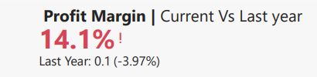

**3. Profit (Current vs Last Year)**

* **KPI:** Profit has grown from **₹38,78,465 last year** to **₹1,30,15,238**, representing a **+235.58%** increase.
* **Main Highlight:** Profit more than doubled, reflecting positive cost management and growing demand.

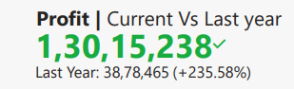

**4. Discount (Current vs Last Year)**

* **KPI:** The total discount provided increased from **₹2,64,674 last year** to **₹8,61,132**, a **+225.36%** increase.
* **Main Highlight:** Discounts have increased substantially, and analyzing its impact on customer retention or increased sales would be useful.

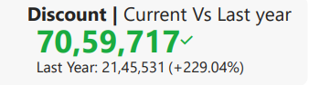

**5. Orders (Current vs Last Year)**

* **KPI:** Orders have increased from **21,45,531 last year** to **70,59,717**, marking a **+229.04%** growth.
* **Main Highlight:** Significant order growth highlights that customer engagement and frequency of purchases have improved.

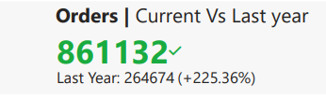

**6. Orders by City**

* **KPI:** Cities like **Lucknow**, **Pune**, **Bangalore**, **Mumbai**, and **Gurgaon** are the top 5 cities in terms of orders.
* **Main Highlight:** The data suggests **Lucknow** has the highest number of orders at **247K**, with other cities close behind, indicating strong demand across multiple regions.

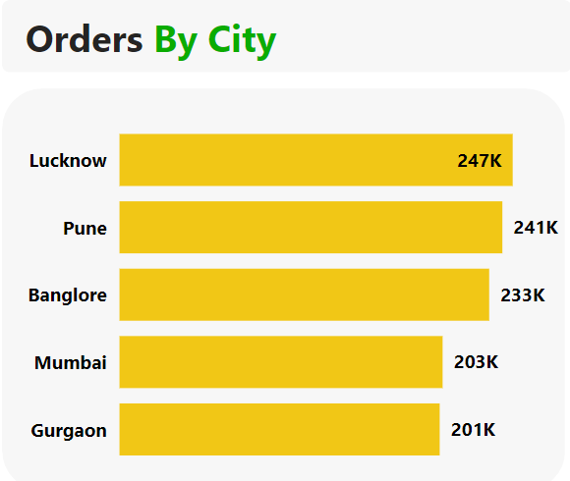

**7. Profit Margin by City**

* **KPI:** The top-performing cities in terms of profit margin include **Gurgaon (15.7%)**, **Pune (15.5%)**, and **Lucknow (14.2%)**.
* **Main Highlight:** **Gurgaon** and **Pune** are leading cities in terms of profitability.

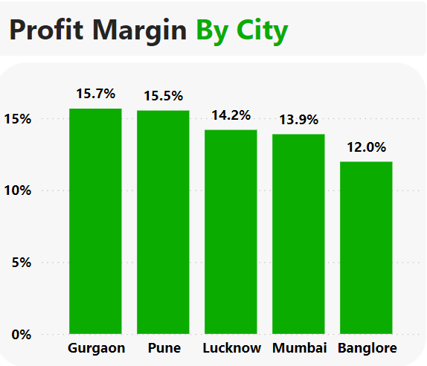

**8. Percentage of Discount Offered by Discount Band**

* **KPI:** The highest discount band is categorized as **High (57.8%)**, followed by **Medium (32.6%)**, and **Low (9.6%)**.
* **Main Highlight:** Most discounts are offered in the high band, which could be a contributing factor to the profit margin dip.

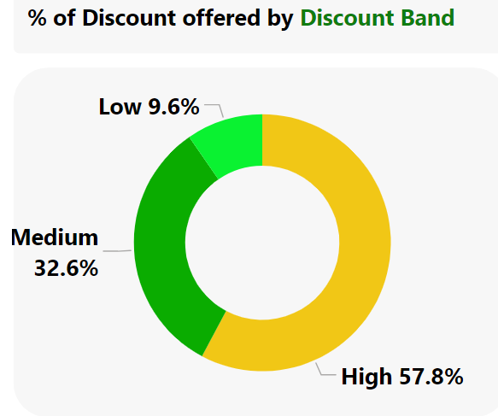

**9. Profit Margin by Category**

* **KPI:** Categories like **Snacks & Drinks**, **Kitchen**, **Beauty & Personal Care**, and **Grocery** have the highest profit margins, with **Snacks & Drinks** leading at **22.21%**.
* **Main Highlight:** **Snacks & Drinks** and **Beauty & Personal Care** are top performers in terms of profit margin.

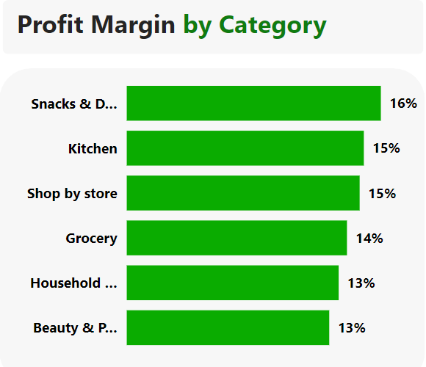

**10. Top 3 Products by Sales**

* **KPI:** Top-performing products include those from categories like **Grocery** and **Beauty & Personal Care**.
* **Main Highlight:** The dashboard helps identify top products that are driving the highest sales, aiding in inventory and sales strategy.

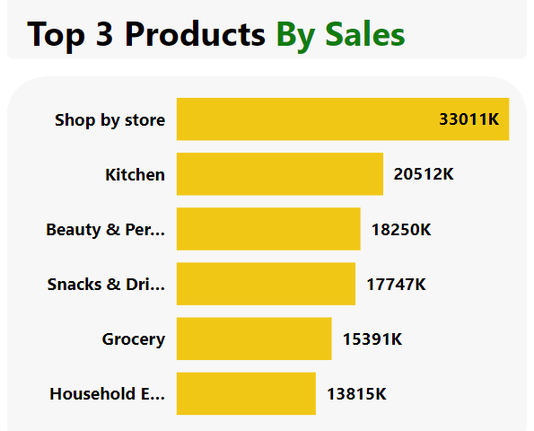

**12. Frequency of Purchases by Segment**

* **KPI:** **Beauty & Personal Care** has the highest frequency of purchases at **73.40%**, followed closely by **Grocery (73.50%)** and **Household Essentials (73.68%)**.
* **Visualization:** A segmented bar chart or table that displays the purchase frequency percentage by segment.
* **Main Highlight:** These segments show consistent customer interaction, indicating strong customer loyalty.